Module 01: Object-Oriented Programming
Language: Java | Type: Pre-lab
Mode: individual practical work

Learning outcomes
By completing this module, you should be able to:
- Distinguish a class, an object, and a reference variable.
- Encapsulate state and initialise objects through constructors.
- Implement inheritance, abstract classes, and an interface.
- Distinguish method overloading from method overriding.
- Explain and demonstrate runtime polymorphism through parent and interface references.
- Test behaviour and justify a design using concrete examples from your code.

Concept Toolkit
Concept | Meaning and a useful distinction
Class and object | A class defines state and behaviour. Each object is an instance with its own identity and instance fields. A reference variable refers to an object; it is not the object itself.
Encapsulation | Keep fields private and expose appropriate operations. A getter can allow reading without allowing arbitrary external modification.
Inheritance | extends expresses an “is-a” relationship and allows a subclass to reuse accessible parent behaviour. Constructors are not inherited.
Overloading | Methods have the same name but different parameter lists. A different return type alone is insufficient. Overload selection uses compile-time types.
Overriding | A subclass supplies a new implementation of an inherited instance method with a matching signature and compatible return type. Use @Override.
Polymorphism | A parent or interface reference can refer to a subtype object. For an overridden instance method, the object’s runtime class determines the implementation executed.
Abstract class | Cannot be instantiated directly. May contain fields, constructors, concrete methods, and abstract methods. A concrete subclass must fulfil remaining abstract obligations.
Interface | Specifies a contract that implementing classes must fulfil. In this lab, its method is implicitly public abstract. Java interfaces can also have other kinds of methods; they are not used here.

Prelab Case: Campus printing service
A campus print shop accepts monochrome and colour print jobs. Each job has an identifier and a positive number of pages. Different jobs calculate charges differently, but a client should request a charge through the same contract. All amounts below are integer rupiah (IDR).
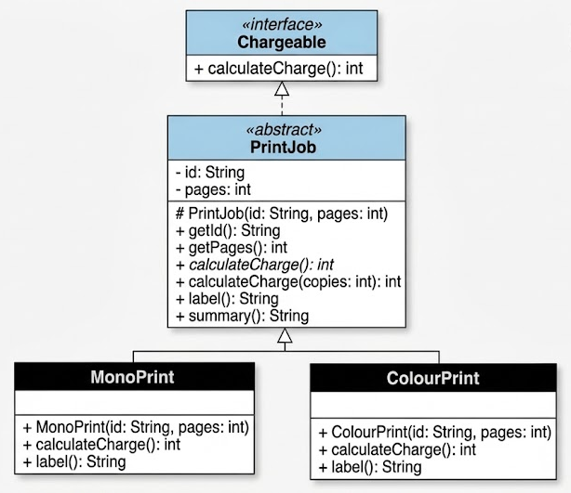

Exact Behaviour
- PrintJob implements Chargeable; both concrete classes extend PrintJob. Initialise inherited state using super(...). No setters are required.
- MonoPrint: IDR 500 per page.
- ColourPrint: first 10 pages at IDR 1,500 each; every page beyond 10 at IDR 1,000; add IDR 2,000 setup per complete copy.
- calculateCharge(int copies) returns copies * calculateCharge(). Implement this overload once in PrintJob; do not duplicate it in the subclasses.
- Parent label() returns "Print"; subclass labels are "Mono" and "Colour".
- summary() returns id + " | " + label() + " | " + calculateCharge(). Do not override summary().
- Throw IllegalArgumentException if pages or copies are zero or negative. Assume valid non-empty IDs, pages at most 100, and copies at most 10. No additional upper-bound or ID validation is required.
- Input File (jobs.txt):
  - Input is read from a text file named jobs.txt.
  - Each line represents one print job with 3 space-separated values: <TYPE> <ID> <PAGES>.
  - There is no header line or total count line at the start of the file.
  - <TYPE> can be MONO or COLOUR.
  - <ID> is the job identifier (e.g., P01).
  - <PAGES> is a positive integer page count.

Prelab Tasks

A1. Implementation and demonstration
- Implement the Chargeable interface and all three classes (PrintJob, MonoPrint, and ColourPrint). Add @Override to each subclass override and to the abstract declaration implementing the interface method.
- In Main, read jobs.txt using Scanner (scanner.next(), scanner.nextInt()).
- Map each line based on its type into a concrete MonoPrint or ColourPrint object.
- Store the created objects in a collection of PrintJob references (e.g., List<PrintJob> or PrintJob[]).
- Print each job's summary() using a single loop through the PrintJob references. Do not select behaviour with instanceof, casts, or type-name conditionals (demonstrating runtime polymorphism).

A2. Required checks
Input file jobs.txt:

MONO P01 8
COLOUR P02 12
COLOUR P10 10
COLOUR P11 11
MONO P12 1

The output of Main must produce the following summaries:

Job / Input | Rate Calculation | Expected summary()
MONO P01 8 | 8 pages × IDR 500 | P01 | Mono | 4000
COLOUR P02 12 | (10 × 1,500) + (2 × 1,000) + 2,000 | P02 | Colour | 19000
COLOUR P10 10 | (10 × 1,500) + 2,000 | P10 | Colour | 17000
COLOUR P11 11 | (10 × 1,500) + (1 × 1,000) + 2,000 | P11 | Colour | 18000
MONO P12 1 | 1 page × IDR 500 | P12 | Mono | 500

The program execution must display exactly:

P01 | Mono | 4000
P02 | Colour | 19000
P10 | Colour | 17000
P11 | Colour | 18000
P12 | Mono | 500

Submission
Please follow these instructions carefully to submit your work:
- Create the lw01 folder under your dsa-[nrp] repository, the repository you created previously in Module 00: Java Setup (check: 0. Java Environment Setup). Inside the lw01 folder, create a subfolder named prelab.
- Complete all of your work for this prelab inside the prelab folder.
- Commit and push your work to GitHub with the commit message:
"Labwork 01 - Prelab"
- Deadline: Monday, September 21, 2026, at 6:00 AM (WIB).
To give a clearer picture, The repository for this semester's practicum will follow the structure below:
